LuxSenz transmitter assembly manual

# Required tools

* 3D printer
* Solder tools

# Part list

* Nucleo-F446RE STM32 Nucleo-64 development board
* LuxSenz USB/amplifier adapter PCB for Nucleo-64 board
* 3D Active shutter glasses, <https://www.gearbest.com/vr-headset/pp_1711709.html> or <https://www.banggood.com/nl/DLP-Link-3D-Projector-Active-Shutter-Glasses-Rechargeable-Battery-Powered-p-1211569.html> or a set of 2 fast switching (>100 Hz) LCD shutters
* Power source, e.g. 2x Flat Li-Ion battery 3.7V 1200 mAh, maximum size 57x67x4mm, with protection circuit
* 1x OPA2325 dual-opamp SOIC-8
* 1x MLCC capacitor SMD 0603 1uF
* 2x resistor SMD 0603 1.5kOhm (or any other value between 1kOhm and 2.2kOhm)
* 1x8 pins pin header 2.54mm
* 1x40 pins (or 2x8) pin socket 2.54mm
* 1x USB female PCB connector, E.G. Samtec Inc. USB-A-S-F-W-TH

# Casing

Use a 3D-printer to print transmitter_case once and transmitter_block_3d_glass_shutter twice. Print transmitter_cap once and transmitter_reflective_shield once in white. The cap and white reflective shield fit together as in the picture below. Note that if other batteries are used than suggested in the part list, the design of transmitter_case and transmitter_cap might require some changes to let everything fit into the casing. The suggested batteries can fit exactly below the Nucleo-F446 board.

The flat parts (transmitter_block_3d_glass_shutter) are meant to hold 2 shutters from the 3d glasses. Solder wires to the connectors of the of the shutters before enclosing them with the 3d printed parts. Together they should have a tight fit into the casing.

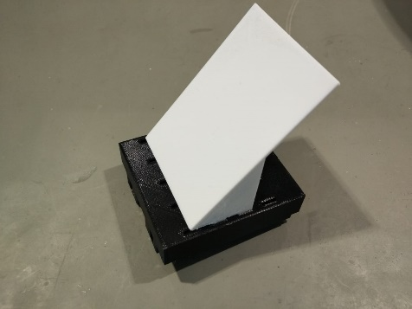

# Expansion board

Solder the expansion boards according to the PCB schematics (view in KiCad) and the 3d images below (USB-connector is not visible in the 3d drawing, but should be on the top side, together with the op-amp and resistors). The Expansion board can be placed on top of the Nucleo-F446RE board. The 8-pin female connector must be connected to pins [2,4,6,8,10,12,14,16,18] of CN7, that is signals [PD2, E5V, GND, NC, IOREF, RESET, +3V3, +5V]. The 2-pin female connector then connects to pins [12,14] of CN10; USB-signals present on [PA12, PA11].

Each of the shutters can be connected to J2 (one wire) and J3 (other wire). A USB keyboard can be connected to USB-connector J6.

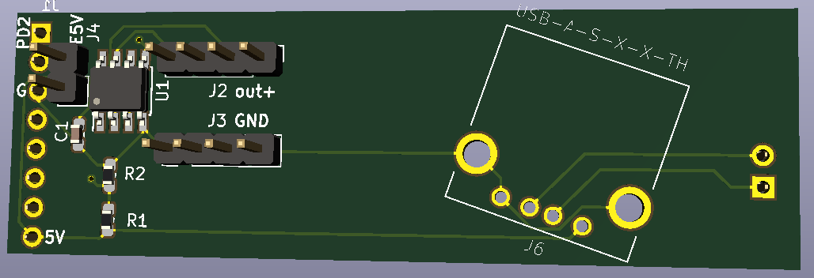 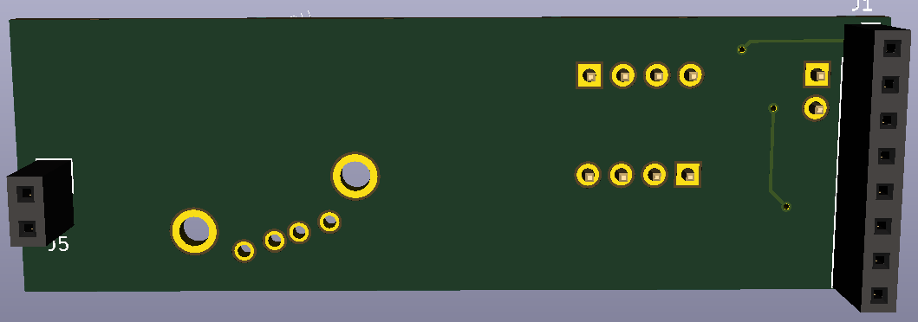

# Powering the board

To power the board, a mini USB cable can be used (then the board doesn’t fit in the casing) when jumper JP5 is set to U5V. To power the board from batteries, JP5 must be set to E5V. On power input VIN (CN6 pin 8 or CN7 pin 24), a voltage source between 7V and 12V can be connected, e.g. 2 Li-Ion batteries connected in series. If a battery with regulated 5V output is available, the power input E5V (CN7 pin 6, or J4 pin 1 on the expansion board) can be connected to a voltage between 4.75V and 5.25V. The jumpers on CN2 may be disconnected to disconnect the ST-Link debugger. See the Nucleo-64 user manual from ST Microelectronics for more details.

# Connecting sensors

Small sensor boards (such as MPL115A2, Si7021 board by Adafruit) can be connected to the Nucleo 64 boards and will fit inside the casing. If I2C is supported, use I2C3_SCL (PA8, CN10 pin 23 or CN9 pin 8) to connect to the I2C SCL pin and I2C3_SDA (PB4, CN10 pin 27 or CN9 pin 6) to connect to the I2C SDA pin. CN6 pins [4,5,6,7] (3V3, 5V, GND, GND) may be used to power sensor boards.

# Programming

To program the Nucleo-F446RE board, jumper JP5 should be set to U5V (USB power) and the jumpers on CN2 must be connected (connection between STM32 and ST-Link on the Nucleo board). Then the board can be connected using a mini-USB cable and programmed with your favourite software.

# Closing the box

The batteries, Nucleo 64 board with expansion board and a few sensor boards should fit into the casing such that the cap can be closed. A USB keyboard can be connected carefully before putting the cap on top of the casing. The transmitter should look like the image below.